Yuan Jingtian

Data Analysis

**Task 1**

**Perform Little's MCAR Test**

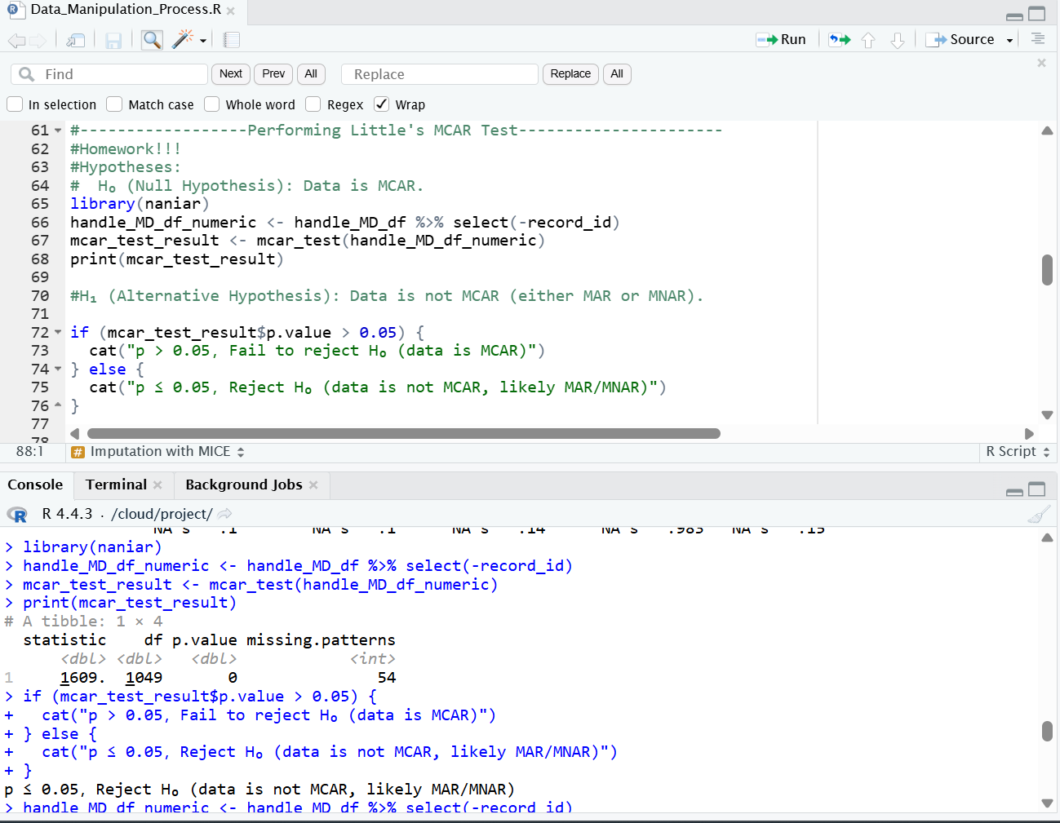

**Imputation Method (method = 'pmm'):**

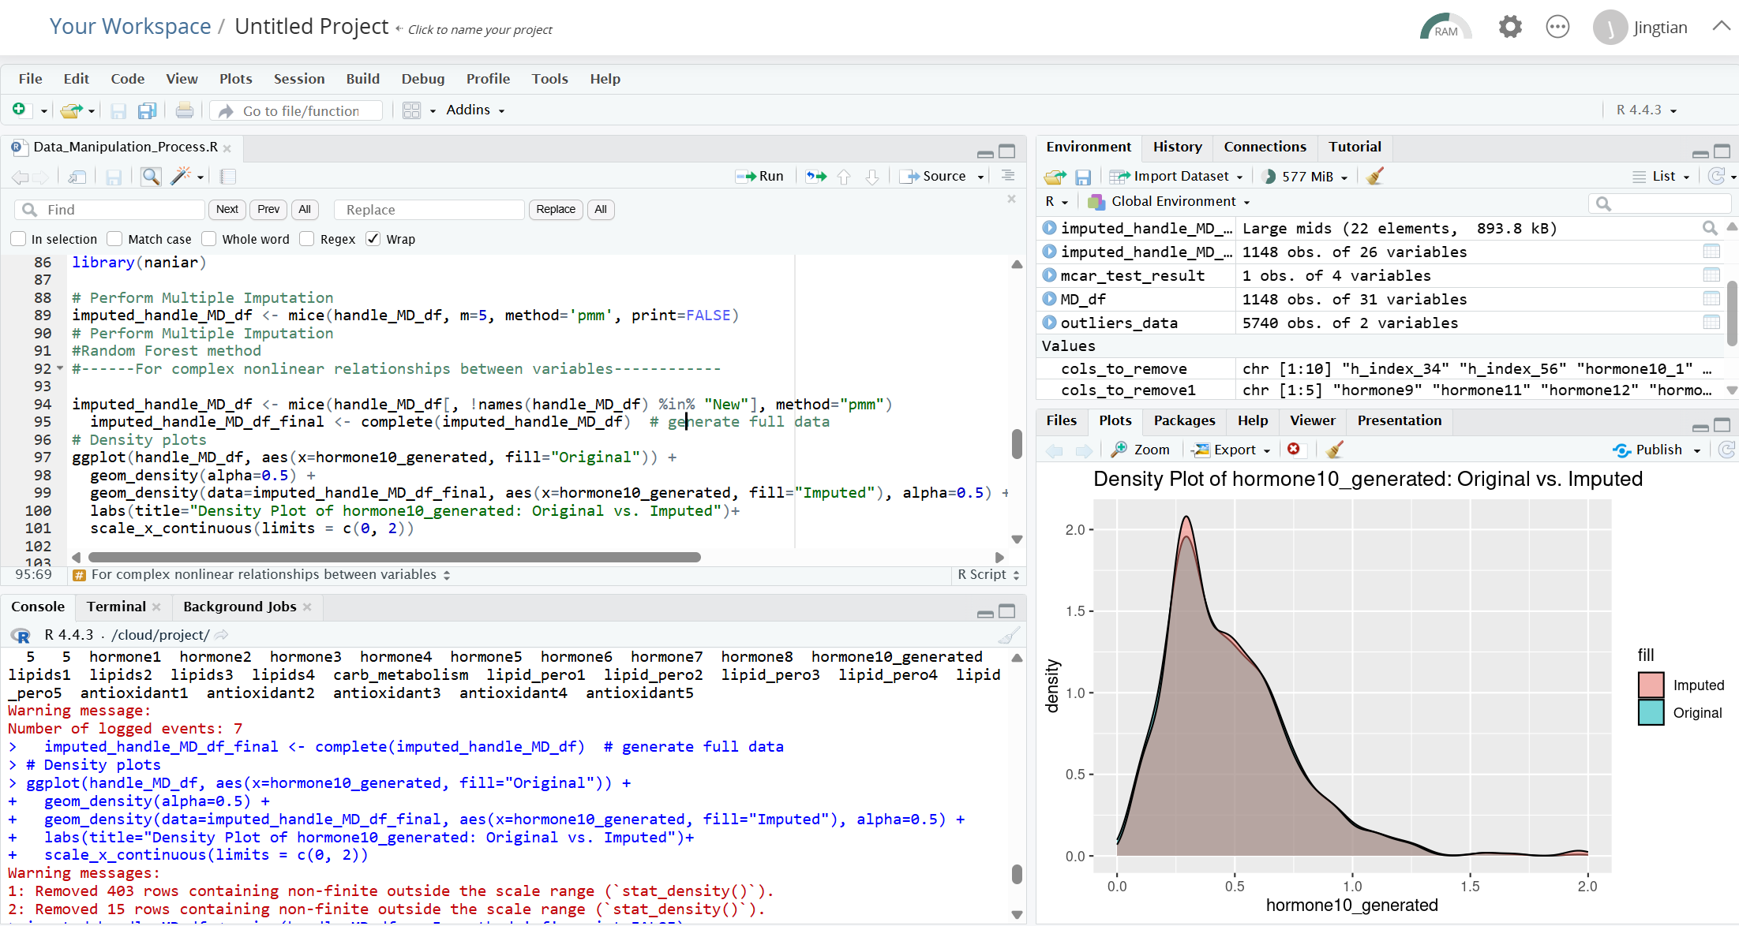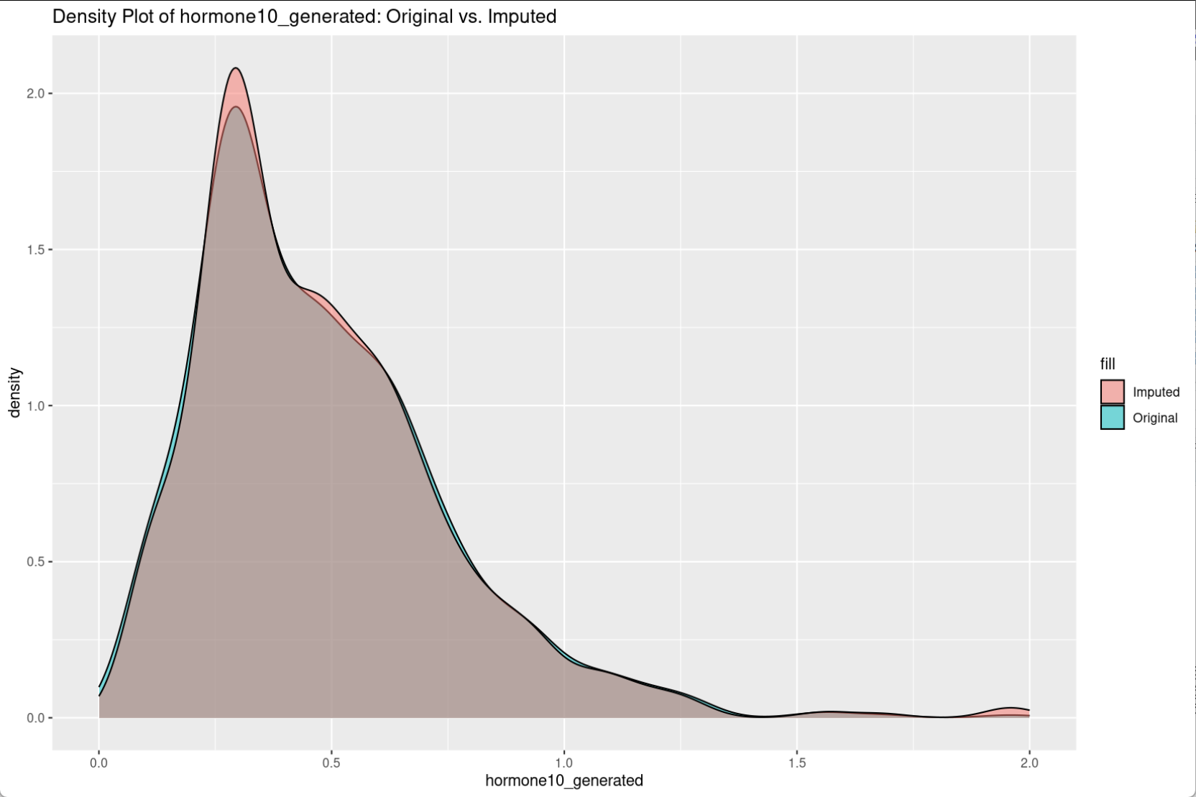

**Imputation Method (method = 'rf'):**

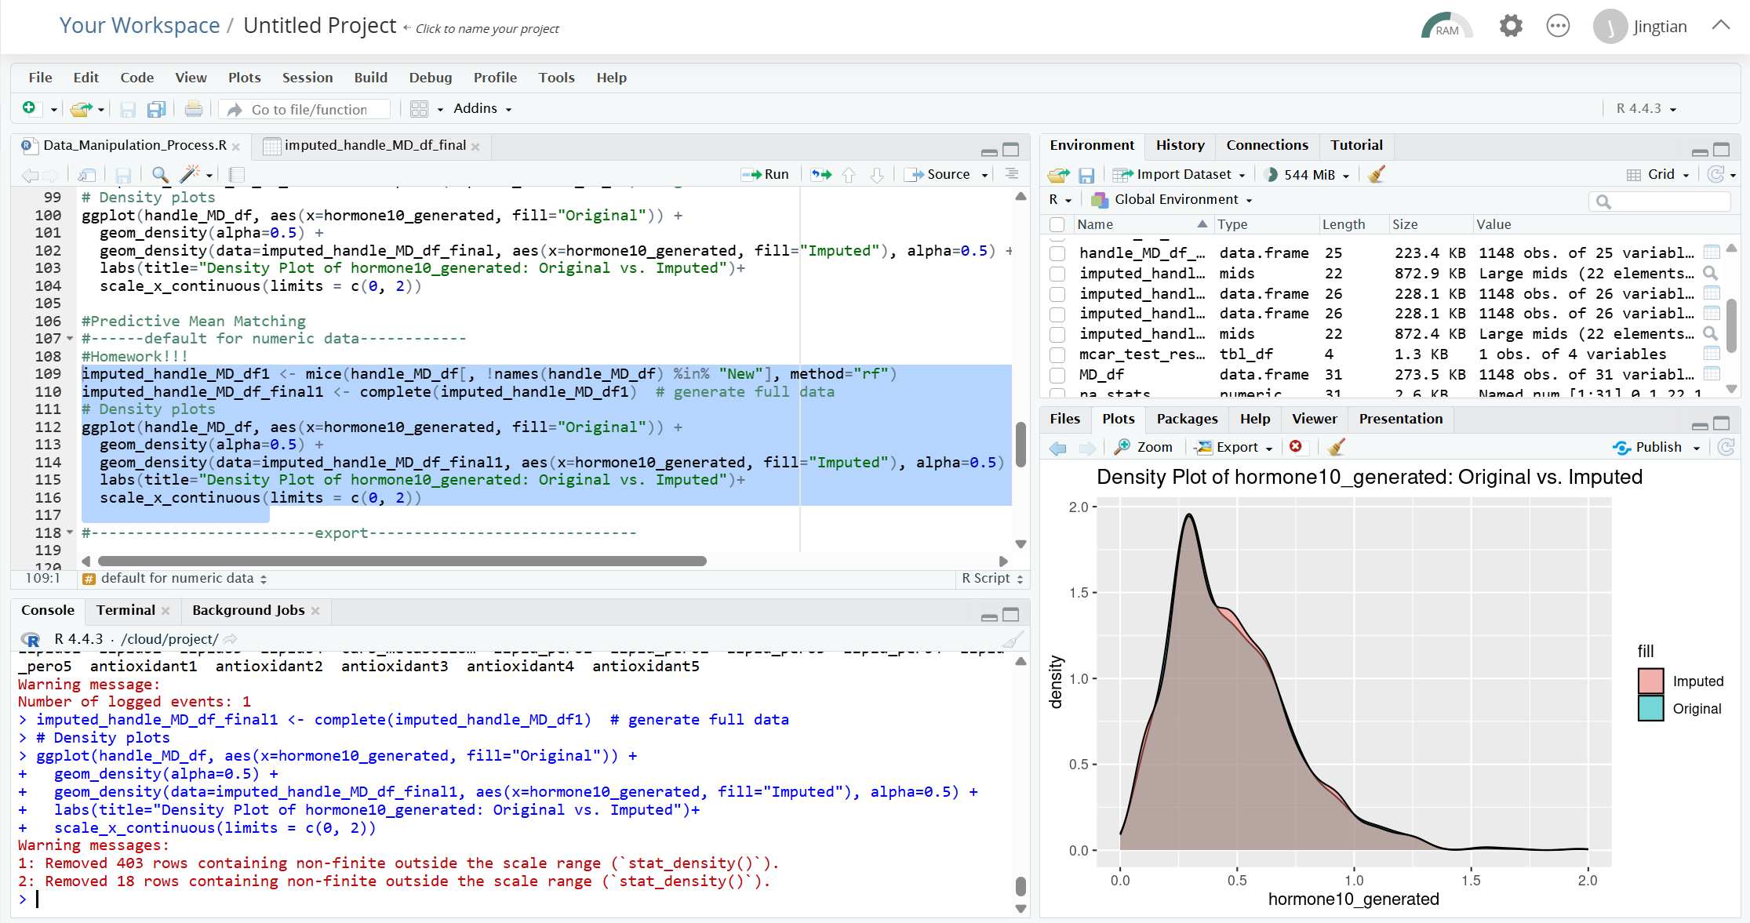

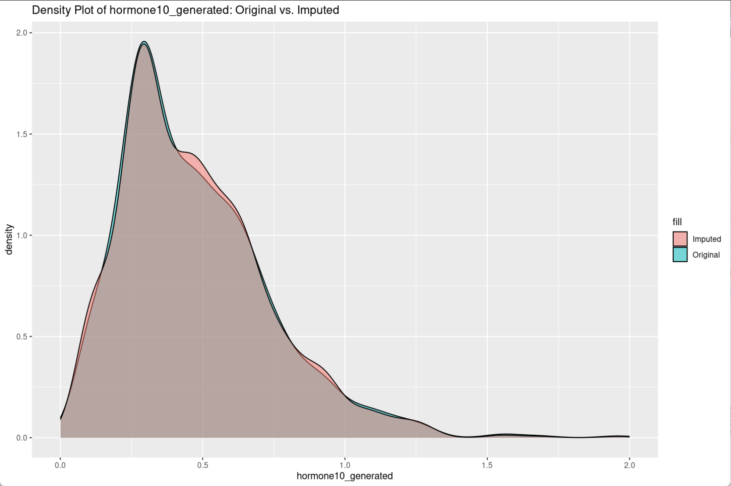

**Conclusion:**

The density range of the ‘pmm’ method after interpolation is far beyond the original data (0.0-2.0), which may result in distortion of the interpolated values due to the failure of the linearity assumption or the existence of nonlinear relationships in the data.

The density profiles after interpolation by the ‘rf’ method are highly overlapping with the original data (0.0-2.0), indicating that Random Forest captures complex variable relationships and preserves the characteristics of the data distribution.

Overall, the 'rf' method significantly outperforms 'pmm' in this case, and better maintains data distribution and biological rationality.

**Calculating LOF factors**

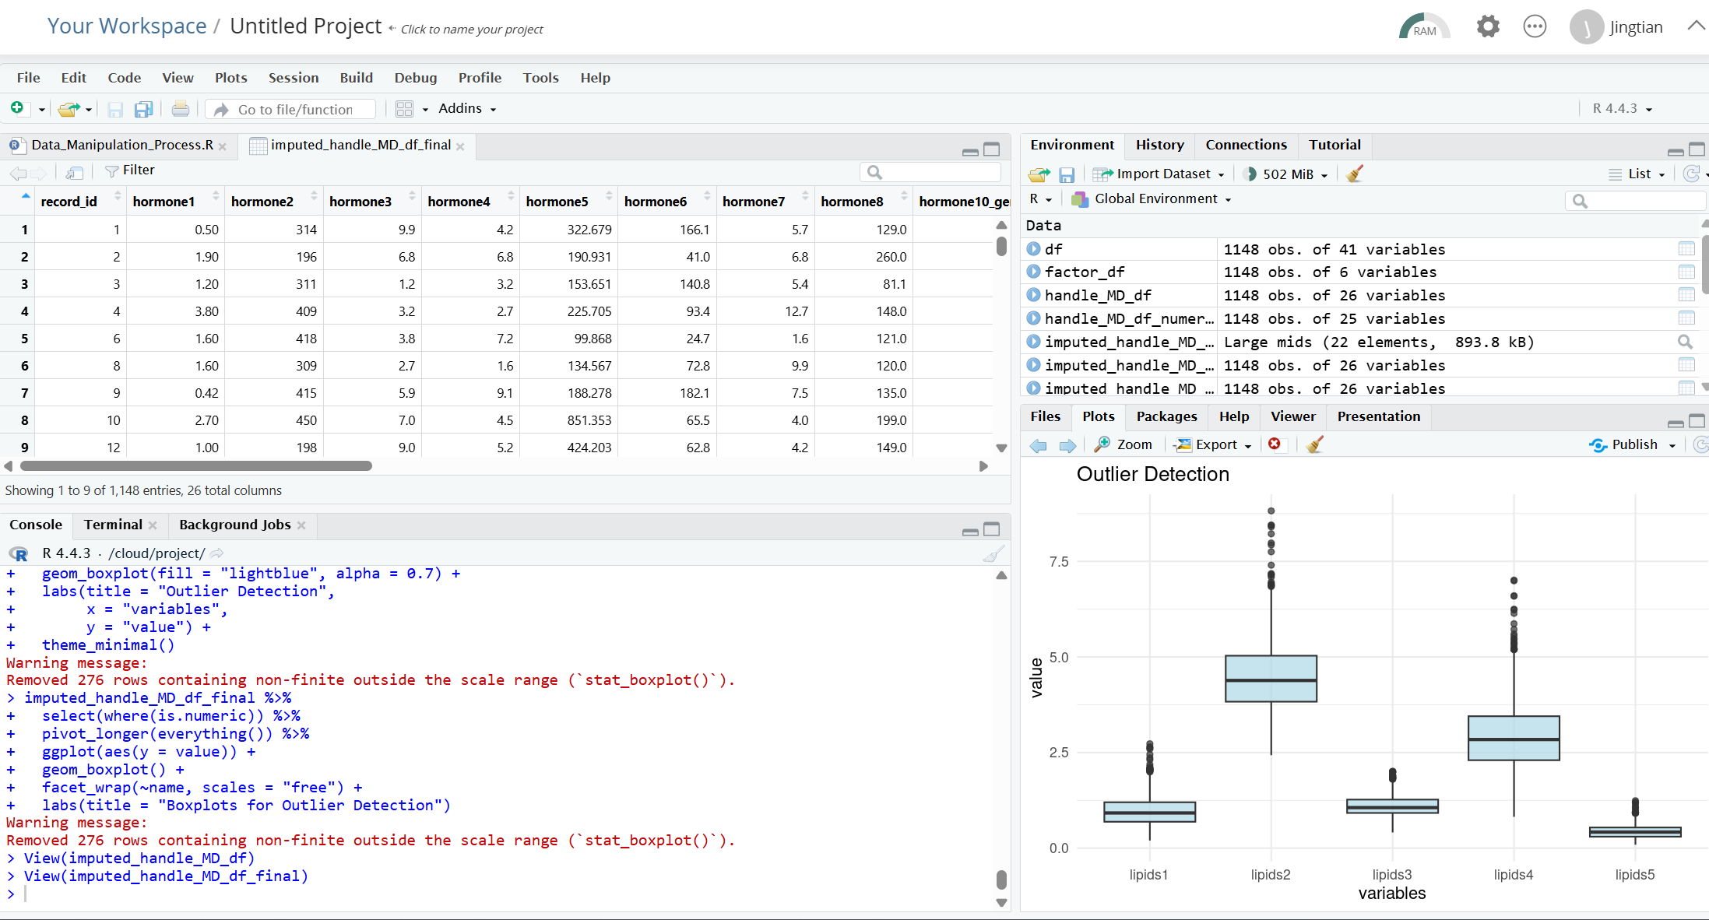

**Visualizing results** 